EVENT

PLANNING

MANUAL

2019

Contents
DISCLAIMER 4
Event Planning Manual 5
Purpose 5
Structure 5
Opening Statement 5
Introduction 5
Hospitality Service Industry Background 6
Definition of hospitality 6
Patch Fee 6
Request for Proposals 6
Place Holder Video 6
Corkage Fee 6
Complimentary Guest Room Ratio 7
Room Upgrades 7
Staff Room Rate 7
Package Receiving 7
Internet Access 7
Attrition Policy 7
Cancellation Policy 7
Diamond Inspected and Approved 8
Developing the Outline – <See Complete Event Checklist> 11
The Objectives and Outcomes of the Event 12
Roles 14
Financial 14
Legal 14
Audio Visual 14
Marketing and Social Media 15
Sponsorship 16
Volunteer 17
Planning the Event 17
Overview 17
Negotiating 19
Venue 21
Program Design 23
Bi-Lingual Event 23
Protocol 25
Group Roles and Responsibilities 26
Employee Time Management 26
Applying for Grants 28
Sponsorship Plan Development 29
Engaging Sponsors 31
Third Party Vendors and Booking Timelines 32
Marketing 37
Media 38
Press Release 38
Event Design 39
Social Media 39
Website 39
Volunteers 39
The Lead Up 41
Prior to the Event 41
Event Day 42
Post Event 43
Evaluation 43
Acknowledgements 44
Appendix 46
Sample Event Budget 46
SAMPLE “Program Greeting” 48
Sample Speaker/Presenter Release Form 49
Sample Delegate Release Form 51
Sample Request for Proposals (RFP) Printing 52
Sample Request for Proposals (RFP) Venue 53
Sample Request for Proposals (RFP) Interpreters 55
Sample Request for VIP Letter of Invitation 56
Sample of VIP Checklist – Premiers Office 57
Sample Service Provider Invitation 59
Sample Save The Date 61
Sample Press Release 62
Sample IRCC National Sector Survey 63
Sample Saskatchewan Language Resource List 71
Complete Example of a Pre-Event Checklist 72
Sample Event Software Requirements 74
LINK to SAISIA Summit Audio Visual Plan, Created by Sami Khiami, PNT “IT” Specialist, AAISA 75
THANK YOU 75

DISCLAIMER – Please note that this document is for information purposes only. While I write this in the first person, I have taken the liberty of making additional notes and highlighting them in RED.

Peggy Robillard, PNT Events Coordinator
Saskatchewan Association of Immigrant and Settlement Integration Agencies, SAISIA

Event Planning Manual

Purpose
The Saskatchewan Association of Immigrant Settlement and Integration Agencies (SAISIA) in an attempt to assist in setting standards for event planning processes that are inclusive of direct and indirect service provider organizations.

Structure
With the assistance of a few of our service provider organizations, SAISIA designed a manual that we believe will provide you with the tools to create a memorable event. The following are suggested topics submitted by our Service Provider Organizations:
- Sponsorship
- Grants
- Employee Time Management
- Templates
- Marketing
- Multi Media/ Social Media
- Budget

Opening Statement

Introduction
Congratulations on deciding to organize an event!
Government sponsored events require much planning. There are many details to take into consideration such as protocols, which must be adhered to in order to meet funding guidelines. This document is designed to assist in the organizing of those details and make the process easier.
This guide will include information and tips from PNT Events Coordinator on topics such as:
• Event development and pre-event logistics
• Hospitality industry
• Solicitation of sponsors
• Marketing tips
• Volunteer recruitment
• Event day management
• Post-event consideration

Hospitality Service Industry Background

Definition of hospitality
1: hospitable treatment, reception, or disposition
2: the activity or business of providing services to guests in hotels, restaurants, bars, etc. —usually used before another noun.
Patch Fee - Audiovisual Patch Fees – Chain hotels and most independents now charge “Patch Fees” for using an outside AV company, meaning not using the company that is paying commissions to them. These fees can range from $50 to $1,000+ per room, per day. We have seen a lot of flexibility from hotels on this, but not from all. Do not make the mistake of assuming that patch fee policies apply across an entire hotel chain, they do not.
Patch Fees are a hospitality sales technique and you should not agree to them. Audiovisual companies go into partnership with a certain hotel chain and pay the venue a finder’s fee when they are contracted to work on an event, this is both profitable to the venue and to the audio-visual service provider, but not necessarily to you, the host. The venue will push their in-house audio-visual company as the expert on their particular establishment, but this is not necessarily true.
Request for Proposals (RFP)– Document created outlining your specific event needs. Your local tourism organization will handle your “RFP” submission and do all the leg work for you.
Place Holder Video - Place-holder videos are the current trend in any live event. When utilizing audio visual providers, a video is created by you, the host to be given to the AV provider prior to the event. There are many variations of place-holder videos. SAISIA utilized a video slideshow with no sound, (SAISIA member organizations submitted photos) in the 2018 event in Regina, Saskatchewan.
Place-holder videos are used on an event big screen during lulls in programming. They are especially helpful when live streaming when you do not want dead air.
Corkage Fee – This is the fee that venues charge customers who bring their own wine to an event. Your venue might charge a corkage fee to help cover their service, for lost revenue from not selling your own wine and for the risk of patrons breaking their wine glasses. Some catering departments try to implement a corkage fee when you have a networking function, which is unacceptable as you are using their spirits. A small fee for bartenders is acceptable.

Complimentary Guest Room Ratio – Most hotels will provide one free guest room night for every 50 guest room nights paid for (actualized by the end of the event), but depending on the market conditions this may be negotiable. Over the last five years, we have seen many hotels agree to a ratio of one free room for every 40 room nights and sometimes they will even do better than that.
Room Upgrades – Do not make the mistake of assuming that the hotel will provide you with a free suite for your Chair. Make a list of the upgrades that you need or want and use that as part of your hotel negotiation. Depending on the number of premium rooms and suites in a particular hotel and the number of rooms you are contracting, a hotel will be more or less generous.
Staff Room Rate – Many hotels will provide a lower rate on group room contracts for a small number of rooms to be used by association staff. This discount ranges from token to significant.
Package Receiving – Many convention hotels are outsourcing their business centers including package receiving to third-parties including FedEx. If you are not careful, these costs can escalate quickly. Be sure to ask hotels to include receiving 10 to 20 boxes and one or two skids within the contract. This can save hundreds or even thousands of dollars if negotiated in advance.
Internet Access – The cost of Internet access in hotels can be a huge issue. It is something that needs to be addressed at the proposal stage and not after the contract has been signed.
Attrition Policy - A reduction or decrease in numbers, size, or strength. This is a major component of the venue contract and can be quite costly if you, the host are in violation. When booking a venue, you negotiate the overall cost of your event based on projected numbers. It is up to you to meet your contractual obligations.
Cancellation Policy – A hotel booking cancellation policy can depend on several factors, such as the rate of the booking and the date of check-in. Depending on the amount of notice given to the venue and on the signed venue contract terms and conditions, you the host may get away with just losing your deposit.
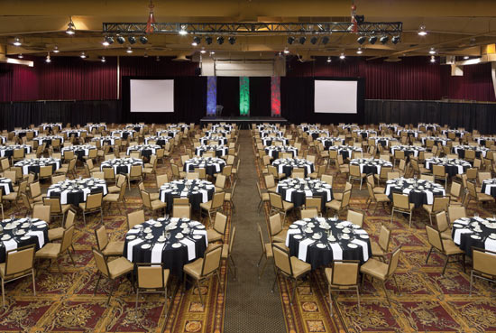

Diamond Inspected and Approved

What It Means to be AAA Inspected & Approved and Diamond Rated?
Hotels and restaurants that meet AAA’s Approval requirements for their category during an unannounced on-site inspection receive the AAA Inspected and Approved designation. Every AAA Inspected and Approved establishment is acceptable for the type of experience it provides; AAA does not approve substandard properties.
For hotels and restaurants designated as AAA Inspected and Approved, inspectors assign a rating of One to Five Diamonds based on the extensiveness of services, facilities and amenities typical of each rating level, indicating the type of experience to expect.

Hotels
AAA Diamond ratings for hotels represent a combination of the overall quality, range of facilities, and level of services offered by the property. The descriptive ratings are assigned exclusively to properties that meet and uphold AAA’s rigorous approval standards.
Budget-oriented, offering basic comfort and hospitality.
Affordable, with modestly enhanced facilities, decor and amenities.
Distinguished, multifaceted with enhanced physical attributes, amenities and guest comforts.
Refined, stylish with upscale physical attributes, extensive amenities and a high degree of hospitality, service and attention to detail.
Ultimate luxury, sophistication and comfort with extraordinary physical attributes, meticulous personalized service, extensive amenities and impeccable standards of excellence.

Restaurants
AAA Diamond ratings for restaurants represent a combination of the overall food, service, décor and ambiance offered by the establishment. The descriptive ratings are assigned exclusively to establishments that meet and uphold AAA’s rigorous approval standards.
Simple, economical food, often quick-serve, in a functional environment.
Familiar food, often cooked to order, served in casual surroundings.
Trendy cuisine, skillfully prepared and served, with expanded beverage options, in an enhanced setting.
Distinctive fine-dining. Creative preparations, skillfully served, often with wine steward, amid upscale ambience.
Leading-edge cuisine of the finest ingredients, uniquely prepared by an acclaimed chef, served by expert service staff led by maître d’ in extraordinary surroundings.

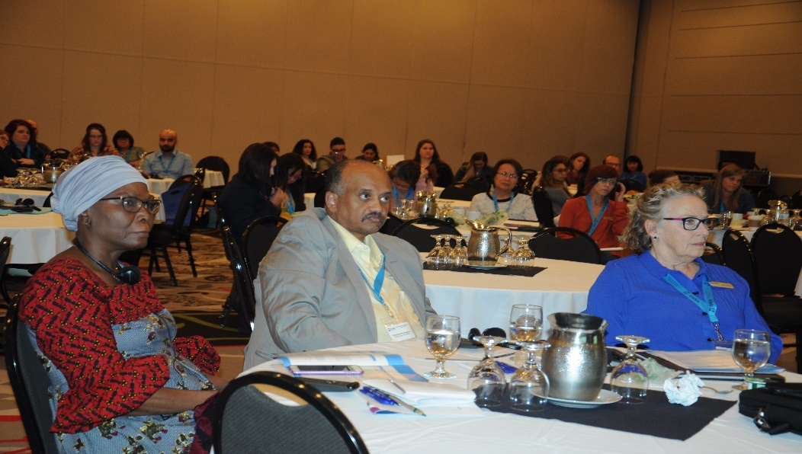

Event coordinators can range in expertise from social to corporate. They aid organizations in coordinating successful events by adhering to an array of duties and fulfilling various roles and responsibilities.
- Customer-Service: Event coordinators deal with clients or guests every day. Customer loyalty begins with good service and friendly demeanor.
- Interpersonal Skills: Being calm and direct in a stressful situation and being able to communicate with many different types of people.
- Leadership: Event coordinators need to be able to motivate their employees, resolve issues and complaints from guests.
- Listening: Excellent listening skills are needed, especially with guests. Making sure that guests are happy and your staff are getting what they need in order to do their job is crucial.
- Management: Working with budgets, planning, creating schedules and supervising operations are all a part of the job.
- Organization: Events have a lot of moving parts, from guests to maintenance, to budgets and scheduling. Event coordinators need to keep it all organized.
- Problem-Solving: Event coordinators need to be able to think quickly on their feet and make decisions when problems come up. Event coordinators must be constantly walking around the venue checking for the following issues:
- Slip and fall- Loose rugs, wet floors, unsecured hand rails, loose electrical cords not secured to the floors properly.
- Food and beverage- You are liable for food-borne illnesses your guests suffer. No outside food allowed into venue. Alcohol consumption, take steps to ensure no minors are imbibing and that adults are cut off when inebriated.
- Security- If your guest is attacked on the venue premises you may be liable due to your lack of security precautions. Poorly lit parking lots, stairwells or hallways, lack of staff identification, broken locks, and absence of security guards.
Example: A guest is injured at a conference, during a hotel stay or when attending a public party, he/she may decide to sue the venue or host, citing negligence and try to prove that the incident could have been prevented.
Delegate/Speaker Release form, releases the Host of all legal responsibility. <SEE template>

Tools for Success
- Event Binder
  - Budget/Financials/Contracts
  - Correspondence
  - Audio Visual
  - Venue
  - Catering
  - Program
  - Speakers
- Cell Phone
  - On 24/7
  - Load all conference materials onto phone
  - Install your email onto your phone
- Record all incoming/outgoing event phone calls

If for any reason you cannot finish what you started and a replacement is required, the new lead organizer will be able to look at your notes and pick up where you left off.

Developing the Outline – <See Complete Event Checklist>

All events start out as an idea, but the key to turning your idea into a great event starts with brainstorming. If your event is small, you may be personally handling most or all of the tasks discussed in this guide. However, for larger events it’s important to bring some passionate people together and talk openly about what community needs exist, topics that excite the group, and ideas that other communities have explored. This is a great way to start the process.
It is important to keep an open mind during this process as sometimes the original idea may sprout into a better idea that is very different from where the group started. It is also a good idea to document the discussion with notes.
Once there is an agreement about the idea for an event, it’s time to develop that idea a little more. This can be done by determining the objectives and outcomes, the audience, and what the wants of that audience will be.
The agenda or program will have the funder utilizing at least a quarter to three quarters of the program. It is imperative that the planning committee determine those exact parameters at the beginning, to offset any confusion and to aid in event program development.

The Objectives and Outcomes of the Event
It’s important to be clear and concise about the objectives and desired outcomes of the event. More often than not, your sponsors or grant applications will ask what these are, so it’s best to address this early.
Questions to Consider:
- What do you hope to achieve from the event, and how will you know when you have succeeded?
- What are some keywords to describe the event?
- The audience of the event
Note: This area of development focuses on determining who your event is trying to reach. Once you have a target audience in mind, you can plan suitable activities and market the event effectively.
- What age range are you looking to target?
- Where does your target demographic live?
- How or where does this audience receive information about events?
- The wants of the audience
Note: Once you have an idea of who your audience is, you can start to determine what type of programming those attendees might want to do.
- What type of experience or message do you want to convey through your activities?
- What type of activities does this target audience typically attend?
- Are the activities within your event budget or your target audience’s budget?
- How much time is needed for organizing?
- What are your volunteer needs?
Note: After these types of questions are answered, you should have a better understanding of whether the event is desired by the community and if your group wants to invest their time in organizing it.

Event Questions:
- Length of event
- Presenters dashboard “wish list”
- Plenary size
- Break-out room numbers (including conference on-site office)
- Catering requirements
- Audio visual requirements
- Free or registration fee
- Private or public event

Example of a Project Timeline
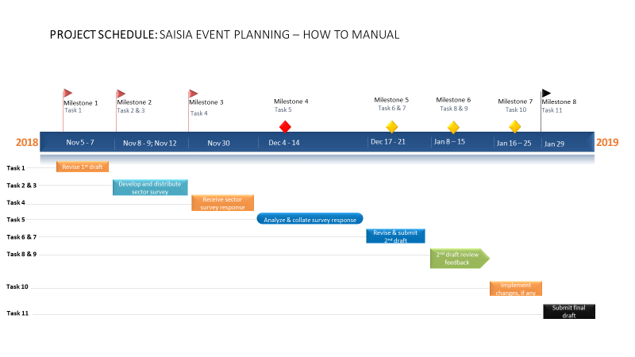

The above outline will give you an idea where planning should start, depending on the event and finances, roles may or may not be expanded upon.

Roles
The event coordinator must ensure that all roles are being fulfilled. These roles often overlap but, in some cases, the event coordinator may want to delegate certain roles to others on their team.

Financial
Create event budget
Help determine sources of revenue
Create invoices for participating vendors and pay for necessary expenditures
Create final report of event revenues and expenditures

Legal
Read over organization funding agreements to ensure the conference adheres to all legal requirements
Work with event management on site plan to submit with special event permit application
Complete and submit special event permit application to city clerk
Obtain and submit event insurance and liquor liability insurance to city clerk
Obtain Right of Way permit for bagged parking meters or street closure from Public Works (if applicable)
Complete and submit tent permit to fire department (if applicable)
Create or sign any third-party vendor contracts for event
Audio Visual
In previous years, audio visual would not have a prominent lead in an event, but now events are dependent on various forms of AV. As a matter of fact, the two most costly factors in any event are now catering and audio visual.
Presentations: Coordinate all plenary audio-visual needs, such as face time, power point, etc.
Request for Proposal: Design audio visual RFP with all event AV requirements, <See AV RFP Sample>

Marketing and Social Media

Most organizations have on staff, at least one person with a rudimentary knowledge of information technology expertise, let this staff person head your social media team.

Event design, adobe is a great platform to help design all your event graphics
Event Letterhead, website, program, and signage
Create advertising and promotional plan
Your event/organization is your brand, if your event is reliant on generating sponsorship, you must have a viable social media marketing strategy.
Work with finance to draw up marketing budget
Create or contract with third-party vendors for event graphics on posters or handouts
Due to financial limitations on event budgets, it is highly recommended to use in-house staff to work on social media.
Generate and update webpage and social media channels before, during, and after event
Create and submit press release to media channels, generally handled by in-house communications person
Submit event to online event calendars
Ensure sponsors logos are included in promotions
Add any volunteer group logos to your promotions
Be sure all marketing deadlines are met
When creating your Printing RFP insert you must design all event graphics and can use the event graphics for all of your design needs.

Sponsorship

Create sponsorship plan and brainstorm list of potential sponsors for your event
Create a database: This is vital to keeping detailed records of all communications with potential corporations
Design sponsorship kit:
- Letter, vitally important to have the sponsorship coordinator’s contact info on all communications.
- Kit, with levels of sponsorship
- Source printers for professional package creation, the more individual you make the package the better.
  - Sponsorship mail merge, the whole production will involve having everything customized to the Presidents/CEO’s/COO’s
  - 500 kits to start, depending on sponsor contact list.
  - Send an email BLAST to staff and board members, give a brief sponsorship strategy update along with your mailing list. Indicate that any help they can provide in securing possible sponsors is greatly appreciated.
    - Indicate that you are issuing customized kits and if they submit the contacts name, title, and mailing info to you, then you can have the kit made. The board member or staff member can be notified when their kits are ready for distribution.
Research potential sponsor values and mission prior to outreach
Reach out and obtain sponsorships for event
Work with marketing and event management to ensure sponsorship expectations are met
Check-in with sponsors on-site at event (if present)
Work with event management on event recap and present to sponsors

Volunteer

Create volunteer plan and work with event management to determine needs for event
Create overview of experience, including date, volunteer times and duties at event
Decide whether to use individuals or groups of volunteers and perform outreach
Work with marketing and event management to ensure promotion of group volunteer organization (if applicable)
Communicate event information and expectations to volunteers prior to event
Manage volunteers on-site at event
Thank volunteers post event, and work with event management to include volunteer experience in event recap

Planning the Event

When entering the planning stage of an event, you want to gather all information previously discussed, and begin the process of envisioning what the day of the event will look like. To do this, you want to develop an overview of the event, assign roles, and responsibilities within your group. You will also need to assess potential venues, purchases, or rent equipment required, based on programming or activity, and look into any possible permitting needed.

Overview

Event Title: Choose a title that reflects the event or the audience. Try to be clear, concise and if possible, catchy.
Date of the Event: When deciding the date for the event, find out what other events might be happening around the same time. Competing with other events may lead to struggles for funding, and potentially low attendance numbers. Upcoming events can be viewed at Tourism Saskatchewan, Alberta, Manitoba, and Tourism Canada.
Save the Date invitation, <See appendix>
Customized organization invitation, <See appendix>
Reach out to your event demographic: Sector Survey
IRCC National Survey for event participants, <See appendix>
Time and length of the event: Try to think about the best time and length that will suit the audience, and the activities that are planned. Some of this may depend on the location of the event, as there are some sound or park ordinances for outdoor events to consider.
Be aware that your funder may want to set the agenda for part of your event.
Event objectives: Clearly state what the event objectives are; this will keep you focused and will also help when applying for sponsorship.
Event outcome: Clearly state the desired outcome of the event. There may be more than one outcome. Bullet points can help make these outcomes to the point and clear.
Description of the event: Put together a short description of your event. This description will assist when initially informing or soliciting individuals and organizations about the event. Press releases will be discussed later in the guide.
Target audience: Describe who your intended audience is, such as the age range, gender, and communities you want to serve. Sponsors will be interested in this detail to assess the economic and social benefits that the event may have on the community and populations reached.
Know your demographics: population, age, and median income.
Number of Attendees: How many attendees are anticipated or desired? For a first-time event, this might be hard to accurately predict, but looking at attendance from similar events might help. Having a general idea of the anticipated attendance will help determine which venue to choose, if additional restrooms or garbage bins are needed, and how much food and beverage to order, just to name a few.
Use previous year’s numbers as a starting point. Keep in mind deciding factors in attendance, three to six months’ notice, number of delegates per organization to receive funding for attending.
Event Programming: List the possible number and type of musicians, vendors, or activities the event will feature.
Tradeshow
Opening/closing ceremonies
Networking
Banquet

Negotiating

“If you know the enemy and know yourself, you need not fear the result of a hundred battles. If you know yourself but not the enemy, for every victory gained you will suffer a defeat. If you know neither the enemy nor yourself, you will succumb in every battle” – Sun Tzu, The Art of War.
Before entering into any negotiation, be prepared, your job is to get the best deal possible for your event.
- Budget, event outline, all RFP’s
- Have a calculator
- Block off one hour and do a sit-down meeting, preferably on your turf.
- Some venues may give you a discount for paying upfront or being a non-profit so it never hurts to ask.
- Room block, based on your numbers from the previous year. Room block is the number of delegate reserved room(s) per night. Generally, the night before the event plus two nights of a three-day conference.
Calculate projected room block numbers by Data Analytics < Projected attendees x Out of town attendees >
The higher the room block per night; the venue will throw more incentives at you. Be aware you will be contractually obligated to meet those numbers.
Remember to set aside the best rooms in your block for your VIP’s and staff (these rooms go under your company credit card)
- Catering, give them your set budget (tax included)
For example: For 200 delegates, I would go $40, 000 (tax included), which would include three hot executive breakfasts, three hot (customized) lunches and six coffee breaks with snacks.
- With this number start negotiating, your goal FREE meeting rooms plus FREE executive accommodations (Get the Presidential suites for your boss and board chair). Be sure to have a Plan B, just in case a Minister or Premier comes. Be prepared to bump one of your bosses out of their room and hustle house-keeping into the room to prep it.
- As event coordinator, it is imperative that you stay at the venue for the duration of the event. It does not matter if you live in the same city, you must stay at the event.
- Ask the venue if they have any decorations, linens, or furniture included with the rental, which would save you money. Ask about free tradeshow set-up (venue provides the linens, tables, and chairs).
- Most venues will provide provincial flag and Canadian flag.
- If you are working with a caterer, ask about ordering food “by consumption,” meaning you only pay if the food is consumed. This generally works for pre-packaged items like snacks or soda.
- Check with venue about donating uneaten food to help organizations.
- As you talk to the representatives of different venues, ask as many questions as possible. Make sure you understand what is included, what is not, and if any special permitting is needed. For example, during summer functions, you may want to have some outdoor activities; this is where extra permitting may be required.
- While negotiating with venues, do not be afraid to stop the talks in order to pull your thoughts together. Explain that you have a lot to think over and will get back to them, being sure to set a call back time.
- Remember, get as much as you can from the venue for FREE.

Negotiation Timeline
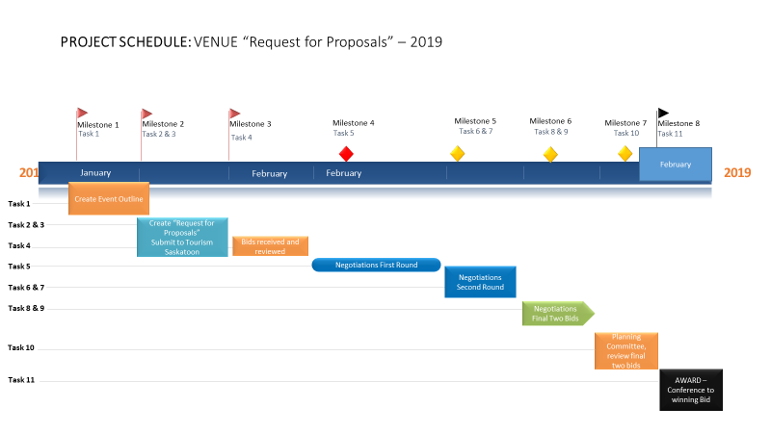

Venue

The right setting for an event can actually generate a positive emotional response and a memorable experience that will bring attendees back year after year. However, choosing a venue that is the right size (or has the ability to grow if your event grows), has a great layout, location, and is within your budget can be a tricky process.
In previous years, the venue was often the single most expensive element of the event. The bulk of your money today is generally going to catering and audiovisual. Here are some tips for keeping costs low:
Some funders may request events be located in one venue so that by working with a single entity, it may give you the ability to negotiate the entire package. A hotel, for example could provide location, food and beverage, security, accommodations and third-party services like audio-visual production.
You may be able to save money and provide an interesting urban experience by using vacant building spaces that are up for lease to host your event. This option would require creative negotiation with the property owner or manager. A possible selling point to a property manager may be that the event will “stage” their space to the public, which could help them get the space leased sooner.
Be sure to enquire about their emergency preparedness, in particular a delegate requiring life saving measures.

Event
Create detailed event timeline, broken down into 30-minute intervals.
Create conference chair itinerary and speaking notes.
Create a detailed map of venue, highlighting all contracted rooms and bathrooms. Ensure all meeting rooms are on the same floor
Each room under contract needs a Room Event Order, this way you are assured exactly what will be happening in all your contracted rooms every day.
Example:
Day One Content
Day Two Content
Day Three Content
Plenary size (Main ballroom/meeting room)
- Room Layout with map
- Number of tables
- Stage, skirted with podium, microphone, skirted table and chairs with microphone
- Number of tables, number of people per table
- Interpreters booth, set-up with water
- Audio visual technicians table with headsets
Break-out rooms, including conference on-site office
- Individual room set-up map with podium, flip charts, markers
- Each room with each day’s presentations ready as handouts
- Conference office, office set-up, tv (set-up to monitor live stream), coffee service
The on-site office is essential to a well-run event because ultimately, there are changes to the program, such as last-minute changes to the presentation.
There is a venue front desk, but they often do not have the capability to make your copies in a timely fashion. They also charge $.20 cents per page for black and white copies and even more for color copies.
Catering requirements
- Absolutely NO pork
- Event order contracts per day, address exactly what will be served each day and at what time
- Special dietary needs addressed
Audio Visual requirements
- Remember to have AV rehearsals the day before the event.
- Ensure audio visual provider is ready as per contract.
- AV coordinator, has all presentations loaded on a flash drive and stays near the technicians table throughout the event to troubleshoot.

Program Design

Bi-Lingual Event
In SAISIA’s case it’s funder: Immigration Refugees and Citizenship Canada (IRCC) handles its own document translation. You however, are responsible for the translation of all outgoing event documents and conference presentations. The general cost per word for document translation is $.23 (twenty-three cents). <See Sample Saskatchewan Resource List>
Greetings
  - Host
  - Federal Minister
  - Provincial Minster
  - Mayor of host city
  - Other VIPs
Logos
  - Host
  - Funder
  - Sponsors – If funding agreement allows
Page One – Outline – Use previous years program as an outline.
Agenda
Introduction
Opening/closing ceremonies
Welcoming greetings by Federal Minister, Provincial Premier, Mayor of host city, and, or VIP with picture to be inserted onto program.
Day one, two, and three
Venue layout, highlight event meeting rooms
Speaker/presenter biographies with pictures
Thank You
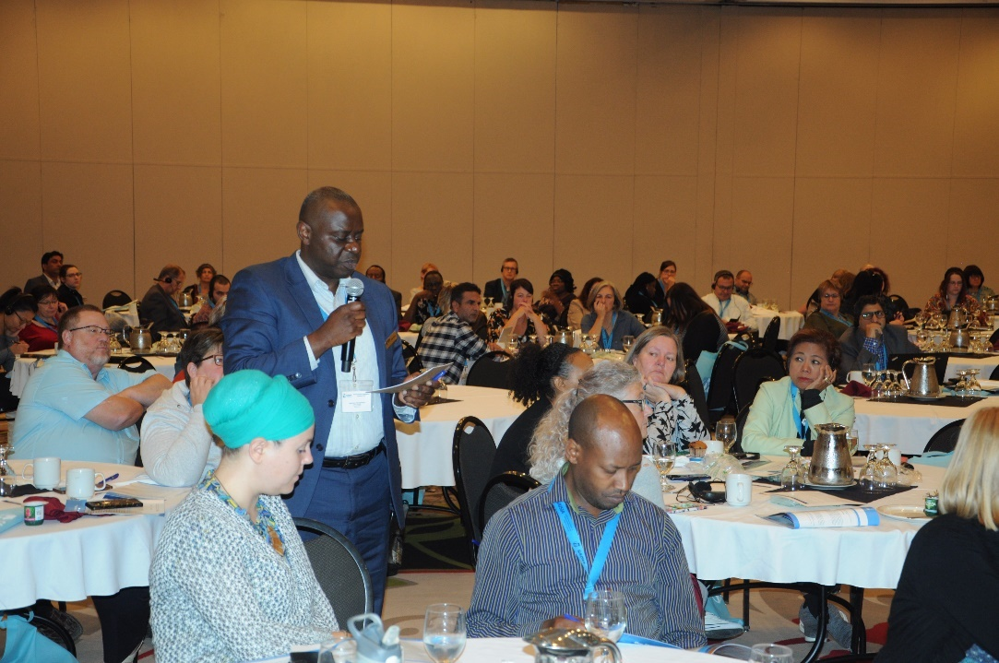

Protocol
“There is no official manual of protocol or ceremonial published by the government of Canada. Protocol, by definition, has to be flexible and adapt to the various players on the political or social stage: an official manual would quickly become the "Protocol Bible" and inflexibility would follow “– Government of Canada
Standard Protocol Template, this order should be followed in order on agenda/program
- Federal Minister
- Provincial Premier
Protocol – For your planning purposes, the host’s provincial Premier speaks first at events unless the Queen, Prime Minister or Lieutenant Governor are in attendance – <SEE VIP Checklist in Appendix>
First Nations Protocol, all First Nations have distinct histories, complex belief systems and diverse cultural and social practices, while unique all First Nations have similar stories in regards to creation and trickster characters. That being said it is important to research your intended demographic and utilize a First Nations cultural consultant to adhere to the particular area in Saskatchewan you wish to include onto the event Agenda.
Saskatchewan
- First Nation population 114,570.00 census Canada stats 2016
- 74 First Nations in Saskatchewan
  - Cree
  - Dene
  - Dakota
  - Saulteaux
  - Assiniboine

Group Roles and Responsibilities
Having a team of individuals assist you in planning the event is very helpful. If you have a team to draw from, this section will help you get the ball rolling! First, it’s crucial to have individuals who are committed and also have the time to dedicate to planning the event.

Employee Time Management
The Saskatchewan Human Rights Code

NOTE:
This consolidation is not official and is subject to House amendments and Law Clerk and Parliamentary Counsel changes to Separate Chapters that may be incorporated up until the publication of the annual bound volume. Amendments have been incorporated for convenience of reference and the official Statutes and Regulations should be consulted for all purposes of interpretation and application of the law. In order to preserve the integrity of the official Statutes and Regulations, errors that may have appeared are reproduced in this consolidation.

EMPLOYEE- Not explicitly hired for coordination of said event and does not have an obligation to employer to carry out said event duties as assigned, if it does not pertain to employee’s employment contract specifically and if said activity adversely affects employee quality of life.

When assigning duties to staff for an event or function, the host should be aware of potential pitfalls, especially if coordinating a big event of 200+ delegates. At least one hour per day should be dedicated to event planning, depending on the function he or she has been assigned. Event communications should be a nine to five, sure thing with no transfers to voicemails and a hard copy, paper message should be taken. With social media today, the instant gratification of reaching someone fast is very important, so be sure to keep in mind that everyone is busy, not just you.

Look at the base skills of the group, do you have a good mix of skills on your team? It’s helpful to have skills in:
Project Management
    - Overall coordination of the event, speaker/presenter coordinator
    - Invitation to speak
    - Honorarium
    - Travel and accommodation
    - Create individual itinerary
    - Plan B in case you need a replacement speaker or presenter

Communication
    - The person who speaks to the press on behalf of the event
Scheduling
    - Creates the event time line, thirty-minute intervals
Sponsorships and Development
    - Oversees the sponsorship strategy
Marketing and Promotion
    - Ensures the event is on track with projected attendance numbers
Creative Design
    - Overall event is visually appealing
Financial Planning
    - Ensures budget is on track
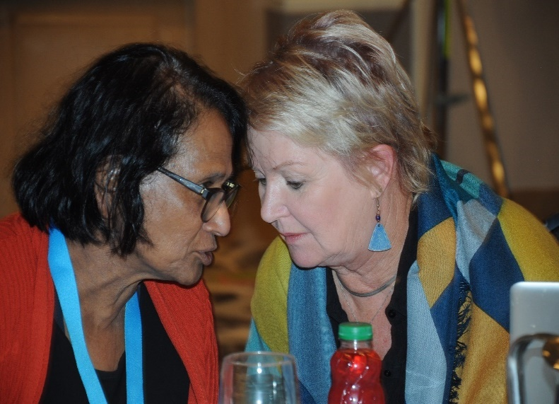
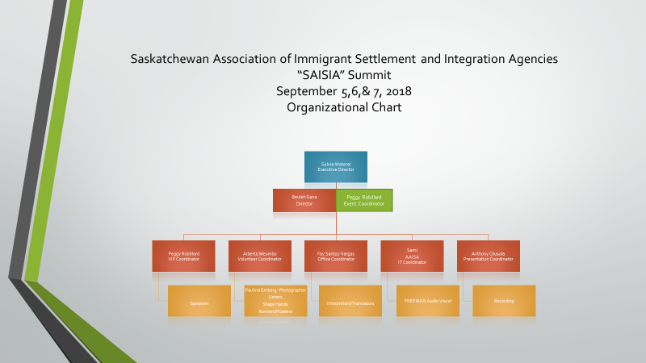
Determining who possesses these skills will help assign roles, define responsibilities, and set a path for accomplishing the event objectives. After reviewing each individual’s skill set and assigning roles, the group should determine a job description, goals, and deadlines for each role.
Budget as you plan the event, you’ll find that your new motto will be, let there be no surprises! This is especially true with the budget; however, you’ll find that there will most likely be some surprises. The more you plan your budget in advance, work in several stages, and stay close to the process, the fewer surprises you will have to deal with.
Begin by listing everything you will need, ideally, for your event. Look over your event outline and use it as a guide when determining your possible needs. Then, look over your list and get estimated costs from third- party vendors. Once you have all of the estimated costs and a total for expenditures, you can either start to solicit sponsors, research and apply for grants, or cut un-needed items from the list.

Applying for Grants
The questions previously asked “Objectives and Outcomes” will be asked by the organization you will be applying for grants from. Potential sponsors will ask these questions and will expect a legible answer.
The Federal and Provincial Governments have programs available that will walk you through the application for funding processes.
Government grants are available if you target a specific demographic for your event audience: children, youth, elderly, Aboriginal, and visible minorities.

Sponsorship Plan Development
It is highly recommended that one person be put in charge of sponsorship. To be successful, a person has to be 100 % committed. Business cards created indicating this person’s job title as “Sponsorship Coordinator” with cellular number and all other contact information.
Load your email app onto your phone, as well as Event Brite/conference registration. Until your event is complete you will live with your phone attached to you.
Load sponsorship packages onto your phone for easy sending. Record who you send packages to and the time and date.
• Create sponsorship strategy
• Create sponsorship package
• Excellent communication skills
• Excellent negotiation skills, this person must have the ability to negotiate with potential sponsors.
It is important to create a strategy when looking for potential event sponsors. What is the benefit for the sponsors? The demographics we represent is immigrant and settlement sector within Saskatchewan; know your population statistics. Below you will find guidance on how to start the process and create a mutually beneficial experience.
• IMPORTANT – Do not connect with potential sponsors via email, sponsor packages are to be mailed.
• Wait two weeks then do a follow-up phone call.
• Timing is everything. Corporations generally meet late January to mid-February to discuss next year’s budget, which means they are already allocating next year’s sponsorship monies.
Create a long list of businesses and organizations that you think would align well with your event. Also include some names that may have access to funding and tend to be highly involved with community functions.
Example: Canada’s List of Top Business’s, including all Canadian banks send a sponsorship package to the President, Canada’s List of Top Millionaires and finally, your host city’s Chamber of Commerce Business Directory
Host City Mayor’s office
Tourism Canada
Tourism Saskatchewan
Tourism Saskatoon
VET Potential Sponsors for integrity and organizationally similar values
Determine Purpose: What are you looking to have the sponsor contribute? There are two ways to work with a sponsor:
1. Sponsor provides a monetary contribution to your event
In this case the sponsor will be referring to the sponsorship package and the levels within.
    - Platinum $25,000.00
    - Gold $10,000.00
    - Silver $ 5,000.00
    - Bronze $ 2,500.00
2. Sponsor and organizer agree upon a trade value
Sometimes, a potential sponsor may only be able to pay for some component on your agenda, such as upgrading a breakfast from continental to executive for example. They may also have the ability to sponsor a banquet, but you currently do not have one on your agenda. Be sure to clarify with the potential sponsor exactly what they plan for the proposed banquet in terms of content and then get the go ahead from your boss to insert it onto your agenda. Another example would be a media sponsor running ads for your event through their outlets where the organizer would provide credit to that sponsor by including their logo on advertisements, social media event announcements, etc.
It is vital for the coordinator of this component to know the budget line items. They should have the authority to negotiate the levels and build the level of sponsorship to cater to the potential sponsor.
Outreach: Now that you have a solidified list of potential sponsors, it’s time to start outreach. It is important to be prepared for the conversation of what you expect from the sponsor and the benefits you would provide them.
Build the agenda for the sponsored function to suit the needs of the sponsor.
Example: If CAMECO is sponsoring the breakfast, check to see if they want to distribute handouts on the tables prior to seating and see if they want to make a speech during breakfast.
Agreement: It is important that you create and execute some sort of agreement between you and the sponsor. This agreement should include the terms you discussed during outreach. Have one member of your organization and one representative of the sponsoring business sign and date after the terms.
Overall, it’s important to remain flexible during this process. Sometimes businesses are not able to provide everything you have in mind, but will still try to contribute in some way when possible.

Engaging Sponsors

You have secured a sponsor, now what? It is important to stay in touch with your sponsors throughout planning, execution, and wrap up of your event. Remember, you want to build a relationship so they will come back as sponsor for your next event.
Example: One on one interaction, introduce your sponsors on your agenda as much as possible, VIP moments, etc.
Pre-event: Look over the terms in your sponsorship agreement. Make sure that you are following through on any commitments to the sponsor. This could include something like, logo inclusion on marketing materials or social media mentions. Stay in touch with your sponsor to ensure everything is running smoothly and to prepare them for any day-of activity.

On-site Presence: Not all sponsors choose to be present during the event, but if they would like to be included, here are some options for doing so:
- Provide a tent area or green room for the sponsor’s guests to gather
- Hang signage (typically provided by the sponsor) somewhere visible on the event site
- Allow opportunity for the sponsor to hand out free branded materials

Post-event: Event recap packets are a great way to show a sponsor the value of their dollars. Important information to include in this packet would be:
  - Event attendance
  - Advertising exposure
  - How many advertisements was their logo included on?
  - What was the reach of those advertisements?
  - Pictures from the event
  - Social media engagement, detailed event analytics
    - Example: Live streaming hits
  - Thank you note
Remember that you are working together to make the event possible! The sponsor’s experience will influence future decisions to work with your organization.

Third Party Vendors and Booking Timelines
The importance of securing and coordinating third-party vendors at an event cannot be understated because vendors act as the infrastructure to hosting a successful event. As mentioned in the above section, a number of venues (especially indoor venues) may already come prepared with third-party vendors and all the equipment you will need.
It is important to note that the venue has a partnership agreement with the audio-visual company onsite and it is in their best interest for you to hire them. You are absolutely not obligated to use their onsite AV company and if the venue tries to impose a Patch Fee to bring on an outside AV company, you may have to walk away from the negotiation table.
Patch Fee: Is a percentage lost due to the venue losing projected revenue.
If you are hosting an outdoor event or have reserved a do-it-yourself indoor space, be sure to consider whether you will need the following types of vendors and when they need to be reserved:

Audio/Visual Production
It’s strongly recommended you reserve these services no less than 6 weeks prior to your event. The more time you can provide the better.
Audio Visual needs are the most important component for the PNT events as we are top heavy, due to our dual live streaming needs. Some venues are technically not prepared to accommodate our requirements. <SEE AV Requirements in RFP Venue Template.>
Negotiate with audio visual providers to ensure rehearsals happen at 1:00 pm the day before the event. Make sure you put this in your contract to avoid any excuses down the road.
NOTE ***Do this after you negotiate price***
This is very important because today’s conferences utilize audio visuals during ninety percent of their event programming through live streaming, place holder videos, pod casts, face timing, etc. If just one aspect fails, that could ruin your whole event.
Interpreters booth and headsets are required, the number of headsets to be determined by each individual Province.

INTERACTIVE and DIGITAL
Videos are the new text when it comes to delivering and conveying information. It is much easier and more fun to not only present information in the form of video, but also to absorb it; especially if done in an exciting and eye-catching way. Invest in a good videographer and editor and you will surely reap the rewards of presentable, high quality content.
Conference Apps: Today’s attendees have limited time to waste and enjoy building their custom itinerary. Check with your AV Bids and see what APP’s they recommend. I do this because there is always new and innovative technology coming out and sometimes your AV provider can use your event as a test subject meaning your event can get FREE technology.
Online Itinerary Planner: Embed a visual itinerary builder into your website so attendees can easily build a personal schedule that seamlessly syncs with the mobile meeting app.
Lead Retrieval Solution: Badge Scanner
Digital Trade Show: The new wave of trade shows, an interactive form of information technology.
Virtual Reality: Active participation example (playing video games on your couch)
Augmented Reality: Passive participation (standing in line at Starbucks playing on your phone)
Event website: Extremely important if your event is hoping to generate money. Potential sponsors will look up your event to gage how important your event is in the grand scheme of things.

WEBSITE CONTENT- Your conference website should get visitors as excited about your event as you are. Which means, welcoming visitors with strong visuals and the most important event details, like what, where and when.

“Call to Action” is a website prompt that tells users to take a specific action, whether that’s submitting, registering, or viewing your conference program.

Home
- Event Information
- Planning Committee
  - Bio’s with headshots
Program
- Agenda
  - Speaker Bio’s with headshots
  - Digital Tradeshow

Registration
- Fees
- Forms

Sponsorship
- Sponsorship Kit
- Delegate Registration, if your event is free “Event Brite” is one free option.
- Create your event
- Insert your letter of invitation to all your invitees
- Public or Private event
- Cost
- Delegate Registration Form
  - Name, title, organization, contact information, dietary requirements, other needs.
  - Will you be staying at the host hotel? Deadline for room block rates. Insert hotel LINK.
  - Insert delegate type: Staff, volunteer, delegate, speaker/presenter, Provincial representative, and Federal representative. This component is important for reporting and detailed event analytics.
Presentations: Coordinates and schedules various forms such as, face time, power point, etc.
It is imperative that every aspect of the AV contract be negotiated and put to paper.
If you require dual live streaming and are not using the in-house audio-visual provider, you will need to bring the venue’s catering department into your final negotiations with potential audio-visual suppliers. Most venues do not include catering in final negotiations so be careful here as the venue and catering are not always in sync.
The venue will need a DEDICATED SSID with required bandwidth.
All the video files from webcasting should be edited and off-loaded directly to the host at the completion of the event.

Music/Entertainment
A good timeframe for booking music or entertainment is four to six weeks prior to the event.
Research your prospects before this timeframe as it can sometimes be a lengthy process to seek out performers.
- Always have a Plan B, for no-shows on the day of your event.
- Petty Cash on hand.

Catering and Bartending
Four to six weeks is a great timeframe to book catering or bartending services for your event. This amount of time will also give you and the caterer enough time to obtain and submit liquor liability insurance or licenses to the host city.
Before signing the contract with the venue, negotiate a specialized menu to emphasize your event’s theme.

Tables, Chairs and Tents
It’s a good idea to reserve these items as soon as possible during the peak wedding season (May – August). In the off season or for very small events, reservations at least two to three weeks in advance.

Portable Restrooms and Wash Stations
Standard portable restroom units should be reserved at least two weeks in advance.
Luxury restroom trailers should be reserved as soon as possible because some weekends can book eight months in advance.
For rural events, sewage removal must be contracted as well.

Waste Collection
For events under 50,000 people, you want to secure trash containers at least 30 days in advance. The collection agency will want to know the type of containers you’re looking to use, the estimated attendance, and the location size of the event.

Event Staffing Services
Larger events (500+ attendees) should reserve staff at least one month prior to event.
Smaller events should reserve staff at least two weeks before event.

Permitting
Understanding what permits your event needs may seem like a daunting task, but fear not. This section will help you determine what permits your outdoor event needs, which city departments to contact, associated costs, permit deadlines, and if additional documents are needed.
Note: Document developed with 2018 information, rates and dates may change.
  - City of Saskatoon Special Event Permit Needed for: events exceeding 300 participants or that plan to have amplified sound
City Department: City Clerk
Cost: $50.00
Deadline: applications must be submitted no less than 60 days prior to the event. For large scale events involving 1,000 participants or more, applications should be submitted no less than 90 - 120 days prior to the event.
Additional Documents: A site plan for the event: a map which shows locations of any stages, portable restrooms, vendor and/or event tents, and activity areas.
  - Special Event Insurance: Events requiring a Special Event Permit must also provide a certificate of liability insurance naming the City of Saskatoon as additional insured. Forms must also include the date, location, and name of the event.
  - Liquor Liability Insurance: Events serving alcohol must obtain a copy of the caterer’s current liquor license and copy of liquor liability insurance specific to their event, date, and location which also list the City of Saskatoon as additionally insured.
  - Street Closure Map & Consent Forms: If asking for a street closure, you must submit a professionally created street closure map (purchased from warning lights to safety signs), and a street closure consent form (included with your Special Event Permit application) approved and signed by any property owner on the closed street).
  - Right of Way Permit: For events asking for bagged parking meters or street closures. Your request for bagged meters or street closures must first be marked on your City of Saskatoon Special Event Permit application, and then you must contact Public Works to confirm and set-up billing. You must also obtain written consent from nearby businesses affected by the street closure (contact Public Works for more information)
City Department: City Clerk
Cost: $6.00 per meter ($3.00 per meter on Saturday and Sunday)
Deadline: Request must be noted on the City of Saskatoon Special Event Permit application under “Additional services requested by any city department?”
Again, applications must be submitted no less than 60 days prior to the event. For large scale events involving 1,000 participants or more, applications should be submitted no less than 90 - 120 days in prior to the event.
  - Temporary Membrane Structures Permit (a.k.a. A Tent Permit)
Needed for: Events using a tent measuring over 200 square feet (10’ X 20’). This application must be filled out by both the event organizer and the company installing the tent
City Department: Fire department
Cost: $55.00
Deadline: Submitted no less than 30 days prior to the event
For events in rural areas, SaskPower must be contacted and they will walk you through their process.

Marketing
Marketing is important for any event. It helps your intended audience and make the event successful. If possible, dedicate at least one person on your team to marketing and preferably, someone who has some knowledge or interest in it. Three main areas within the realm of marketing to focus on are Print, Media, and Digital. Within each of these areas are examples of avenues and channels you can utilize to market your event and tips to consider while doing it.
The person in charge of marketing your event should know every aspect of the conference. Marketing and sponsorship go hand in hand and a strong sales background is crucial as you are selling your event. They must have the authority to negotiate with potential sponsors on their level and the knowledge of the event to be able to sell sponsorship of specific components. For example, if a potential sponsor indicates that they only have $2,500.00 available, then you could say that you have an opportunity for the sponsor to look at, which would be co-sponsoring the networking function with another group.
Handling marketing and sponsorship should be directed by one person, it is important that the left hand know what the right hand is doing.
The ONUS is on you to bring in the money for your event. If due to budget concerns, you had a continental breakfast scheduled, see if a potential sponsor would like to sponsor an executive level breakfast. Sometimes you need to be creative to bring in the money.

Media
After drafting and finalizing your press release, it is worth reaching out to local news media to earn pre-event coverage. You can find a complete list with a Google search.
When pitching your event to local media, it is important to keep your message short and concise, but be sure to include highlights about your event that will make it stand out from similar events in the past, present, or future.
Highlight what makes your event unique such as, VIP’s, cultural performer’s, ethnic themed meals, high profile sponsors, etc.
Newspaper and other Print Publications
You may choose to publish advertisements with the local newspaper or other printed publication. If this is something that is in your budget, you can find contact information within each newspaper or printed publication. The largest newspaper in Saskatoon is the Star Phoenix.

Press Release
Is prepared for media inquiries/interviews about the event <See Sample Press Release>.
Prepare an official press release that is no longer than one page in length (using no less than 11-point font or no more than 12-point font). Include a point of contact (for media or general purposes), your organization’s name, and contact information (phone and email).
Include “FOR IMMEDIATE RELEASE” and the date of which the press release is
published/distributed.be sure to include the five W’s:
Who
What
When
Where
Why
Distribute your press release to local media about one day before your event. You can find general contact information on their website. Be sure to keep the email containing the press release as short as possible.
Note: As a courtesy, refrain from sending your press release to individual reporters unless you have already built rapport with a particular individual.

Event Design
Design an event poster and distribute them around town at key strategic locations that relate to your target audience. Be sure to obtain permission before posting.

Social Media
ONLY for public events - Create a Facebook event. Use this social media tool to publish updates and information about the event and engage with other users on social media about your event. Be genuine in your communications utilize other social media platforms like Twitter, Instagram, YouTube, Google+, etc.
  - Digital Online Calendars
There are many free online calendars to publish your event on. Many of the local news media also have online calendars. Submit your event at these locations.
A simple Google search will help you find other community calendars to list your event.

Website
Create a website if this is in your budget. There are free options; however, be sure to do your research before opting for a free website or investing in a paid option.

Volunteers
It cannot be understated that good volunteers are crucial for a successful event. These individuals are many times the frontline representatives of your event, so it’s important to select individual volunteers or volunteer groups who are positive and committed to your cause. Your first piece of business when soliciting volunteers is to determine your event needs. Do you need greeters, cleaners, or just helpers that can move equipment? Identify your areas of need, then make a list of duties your volunteers will need to perform. For example: Clean-up and teardown/collection of tables, chairs, and roll-away garbage containers.
Duties: Collect trash throughout the event and place in roll-away trash containers. After the garbage is collected, tear down the tables and chairs and move them to the pick-up location. Collect all trash containers and move them to the pick-up location, making sure to perform a final sweep for garbage within the event site. Next, take into consideration your event timeline, how many volunteers it will take to perform said duties, and the potential attendance of your event. Be sure to take some time with this part as some believe recruiting a large number of volunteers will make their event go more smoothly. In reality, having a large number of volunteers may involve a considerable amount of coordination and communication on the event day, which might be difficult for you and your team to spare. It’s helpful to sit down and talk through these considerations with your planning team.

  - Individual Volunteers vs. Groups
Once all of your volunteer roles, duties, start/end times, and numbers figured out, you’ll need to decide whether to work with a group or individual volunteers. There can be benefits and challenges to working with either one which are highlighted below. Be sure to give it some thought, and select the type that feels right for your event.
Group Volunteers: Usually employees of a business or members of an organization and have a designated leader (e.g. the United Way, the Salvation Army, or a high school sports team).
- Benefits: Instead of trying to recruit and communicate with a number of individuals, you will usually coordinate with one person. The group leader working with the groups can be helpful when you need to recruit a larger number of volunteers for an event. Usually, the individuals within the group know one another and work well together.
There is greater accountability for the volunteers to show up to your event because they don’t want to let their group members down
- Challenges: The nature of activities within your event may prevent you from working with certain groups. For example, an event that serves or features alcohol will likely prevent youth or certain non-profits from participating. Sometimes groups ask for or require a donation to their organization for participating, which may not always be possible within an event’s budget
Make sure you clearly communicate the maximum number of volunteers needed and your expectations with the group leader before the event.

Individual Volunteers: Are people who have either been recruited or have expressed interest in volunteering their time for your organization or event.
- Benefits: You might have the opportunity to work with a volunteer who is really passionate about your cause or event.
Individuals can sometimes bring greater diversity, perspectives, and experience to your event. Sometimes, an individual volunteer can end up being someone one who really stands out and becomes a larger player in your future events.
- Challenges: Communicating your expectations and event information with a large number of individual volunteers can sometimes be challenging.
Without a leader or group to hold them accountable, an individual volunteer may not show up to your event. If you need a large number of volunteers for your event, it may take a long time to recruit and orientate individuals.
Although rare, differences in personality amongst your volunteers can sometimes have negative consequences for your event.
Whether working with a group or individuals, it’s important to have clear and concise communication with your volunteers before and during the event. After the experience, reach out to your volunteers and ask them what part of the experience they enjoyed, and what could be improved. Their feedback, whether good or bad will help you grow your skills in this area and make you a better event organizer overall.

The Lead Up
The day you’ve been waiting for is fast approaching, and you may be feeling excited or even a little anxious. The two weeks prior to your event will be over before you know it, but in that time you and your team will want to re-confirm information and put the final touches on your event. The following is a general event checklist designed to help you get started in identifying all of the details you’ll need to keep in mind, along with an indication of suggested times leading up to the big day.

Prior to the Event
Check RSVP or ticket sales and send final attendee numbers to your caterer.
Re-confirm event dates and times with presenters and performers.
Hold pre-event meetings with third- party vendors, managers of the venue, and volunteers.
Do one last walk-through of venue and all event spaces.
Make nametags or lanyards to designate staff and volunteers.
If a ticketed event, send final information BLAST to attendees including directions, maps, and last-minute details.
Discuss severe weather logistics with planning team (if hosting an outdoor event).

Days Prior to the Event
Create a final to-do list to ensure all of your tasks are completed.
Make sure you have important contact numbers for venue managers, third-party vendors, volunteers, or non-emergency police in one place and easily accessible on the event day. It is helpful to laminate these and put on your staff lanyards.
Reconfirm schedule with your caterer.
Deliver materials/equipment to the venue site (if possible).

Event Day
The day of your event will go by quickly, and no matter how much you plan, unexpected things will arise. If something comes up, be sure to utilize the resources you have on hand such as:
• Your planning teams
• The volunteers
• Conference office
It will also be important to arrive to the venue early and stay until the end of your event. Doing this will ensure you can do a final walk through before and after the event, and monitor your third-party vendors to oversee their set-up and teardown, making sure they’re adhering to venue policies.
As event lead you do a walk-through of all the meeting rooms (6:00 am). Bring a member of the catering staff with you and NEON sticky notes, adhere sticky notes to area’s that need to be fixed (with notes on them).
- Check each table cloth for stains, rips, and/or general wear and tear.
- Main Plenary – Audio visual technicians should be ready to start one hour to program start.
- Play music
- Upload place holder video
- Interpreters/translators should be ready and briefed on the day’s events, Interpreters are provided all materials used in the upcoming presentations
- Start at 6:00 am because the catering staff need time to fix areas of concern before the event begins.
- Half hour before your functions start, check all the rooms to see if catering made all of your changes.
- For breakfast, check the serving stations, address dietary needs and make sure AV technicians and interpreters eat.
Conference office, ensure everything is set for next few days. T.V. (compliments of the venue) should be set-up to monitor “Dual live streaming”.
- Whoever is monitoring the live stream should have a direct line to the AV technicians table to address concerns.
Once everything is up and running, be sure to check in with all of your sponsors and volunteers throughout the event, and stick to your plan as best as you can. Also, take some time to enjoy the event and relax, your hard work is paying off!

Post Event
After your event, you will be tired in both body and mind, so be sure to reserve the following day to recuperate and rest. You will have earned it! However, in the following week you will want to evaluate, acknowledge, and recap the event. Each of these follow up areas are important and expected by those in the community who participated in and provided assistance to your event.

Evaluation
Make sure this follow-up discussion is conducted with your planning team very soon after the event, while the information is still fresh in your minds. Your team will want to honestly discuss and record the successes or challenges. Remember to provide constructive and critical feedback, and if something didn’t go well, ask how it could have been improved.
Suggested questions might include:
1. Was communication with third-party vendors, entertainment, and volunteers effective?
2. How did your third-party vendors, volunteers, and entertainment perform?
3. Was the venue a good choice for your event?
4. If your sponsors were onsite, what was their opinion of the event when you spoke with them?
5. How many attendees were there?
6. How did attendees engage with your activities or respond to your programming?
7. Did the media show up to cover event? If so, who came and what type of coverage did you receive?
8. Were you able to stick to your budget?
9. Did you achieve your goal or objective with the event?
10. Do you think the event had an impact on the community? If so, what was that impact?
11. Would you hold this event again?
These questions are just helpful suggestions, and your group will no doubt think of others that are more specific to your event from items that came up.

Acknowledgements

Saying thank you to everyone who assisted with your event is not just a nice thing to do, but it also ensures the relationships you created end on a positive note. Make sure to give thanks and acknowledge the contributions of:
Sponsors
Volunteers
Speakers or presenters
Entertainers
Third-Party Vendors
Any media outlets who provided coverage
In the thank you notes, be sure to remind the recipients of the event’s success and how they contributed to it, including the impact on the community, dollars raised, number of attendees, etc. You can send these thank you notes via a personally crafted email, or in the mail with a physical note. Either way, put some thought into each of them, and avoid sending a large impersonal email blast.
The End
While this is the end of the planning guide, we here at the Saskatchewan Association of Immigrant Settlement and Integration Agencies hope this is not the end of your interest in event planning. Events and engaging with the community are essential for establishing Saskatchewan as a place that is vibrant, urban, and inviting to residents and visitors.
If you should have any questions about the information contained within this guide, please contact our office Monday – Friday from 9:00am – 5:00pm at (306) 651-4390 or via email at info@saisia.ca
We are happy to answer your questions
Good luck and happy planning!
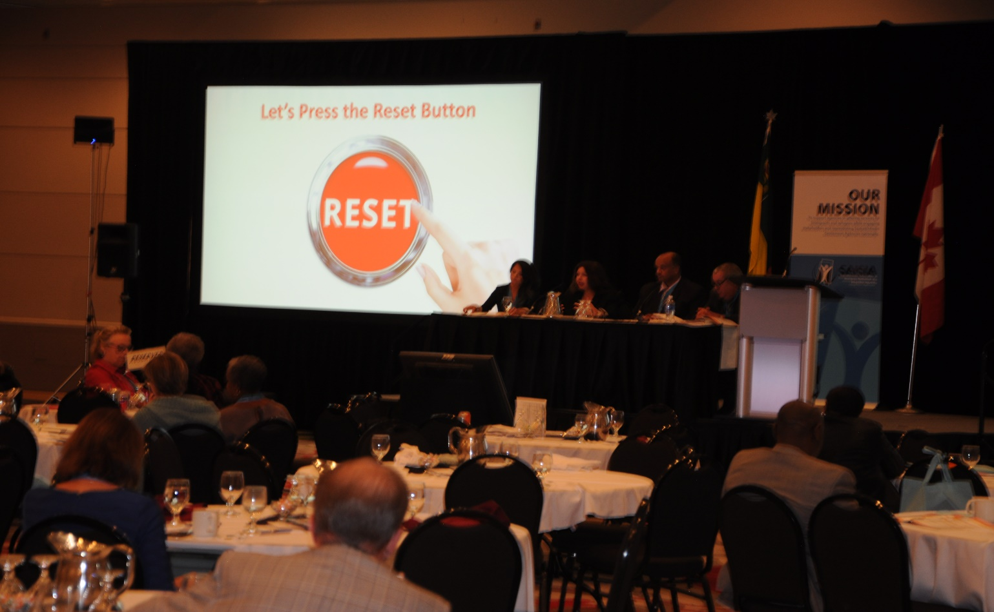

Appendix

Sample Event Budget
 | Venue
 | CATEGORY | ESTIMATED | ACTUAL | OVER/UNDER
 | Main Meeting Hall | 0.00 | 0.00 | 0.00
 | Break-Out #1 | 0.00 | 0.00 | 0.00
 | Break-Out #2 | 0.00 | 0.00 | 0.00
 | Break-Out #3 | 0.00 | 0.00 | 0.00
 | Break-Out #4 | 0.00 | 0.00 | 0.00
 | Break-Out #5 | 0.00 | 0.00 | 0.00
 | Conference Office | 0.00 | 0.00 | 0.00
 | Green Room | 0.00 | 0.00 | 0.00
 | Venue Total | 0.00 | 0.00 | 0.00
 | Catering
 | CATEGORY | ESTIMATED | ACTUAL | OVER/UNDER
 | Networking | 0.00 | 0.00 | 0.00
 | All day package (b'fast, lunch & 2 health breaks) $70./person*150 participants | 40,635.00 | 0.00 | 40,635.00 |  | 29% Service Charge and GST
 | Banquet $50./person | 0.00 | 0.00 | 0.00
 | Catering Total | 40,635.00 | 0.00 | 40,635.00
 | Audio Visual & Livestreaming
 | CATEGORY | ESTIMATED | ACTUAL | OVER/UNDER
 | Equipment |  | 0.00 | 0.00 |  | FREEMAN
 | Consumables |  | 0.00 | 0.00
 | Labor |  | 0.00 | 0.00
 | Delivery/pick up |  | 0.00 | 0.00
 | Tax |  |  | 0.00
 | Audio Visual &live streaming Total | 30,000.00 | 0.00 | 30,000.00
 | Communications
 | CATEGORY | ESTIMATED | ACTUAL | OVER/UNDER
 | Interpretation Services | 6,200.00 | 0.00 | 6,200.00 |  | Saskatchewan Interpretation Services
 | Conference Programs | 3,000.00 | 0.00 | 3,000.00 |  | 2 Interpreters @ $700./day plus Perdiem @ $75. each/day
 | Summit supplies (package, name tags, scribbling pads etc.) | 4,000.00 | 0.00 | 4,000.00 |  | Document Translation @$.23/word
 | Document Translation (.23/word) | 2,000.00 | 0.00 | 2,000.00 |  | $5.00/program X #200 English plus #50 French
 | Note taking/recording | 2,000.00 |  | 2,000.00 |  | Court Transcribers @$300. each/day | x 2 days
 | Report Translation to French | 7,000.00 | 0.00 | 7,000.00
 | Printing Report | 1,000.00 | 0.00 | 1,000.00
 | Signage | 1,500.00 |  | 1,500.00 |  | Banner $900.00 Break-Out Signage $1000.00
 | Communications Total | 26,700.00 | 0.00 | 26,700.00
 | Speakers
 | CATEGORY | ESTIMATED | ACTUAL | OVER/UNDER
 | Air Travel | 1,500.00 | 0.00 | 1,500.00
 | Ground travel | 500.00 |  | 500.00
 | Accommodation $149./night | 596.00 | 0.00 | 596.00
 | Breakfast $20/day | 80.00 | 0.00 | 80.00
 | Supper $42.45/day | 180.00 | 0.00 | 180.00
 | Honorarium | 1,000.00 | 0.00 | 1,000.00
 | Incidentals | 400.00 | 0.00 | 400.00
 | Speakers Total | 4,256.00 | 0.00 | 4,256.00

BUDGET:
Estimated Revenues: List all sources, including in-kind donations.
(Subtotal of Estimated Revenues – Subtotal of Estimated Expenses = Grand Total)

SAMPLE “Program Greeting”
Greetings
Welcome to Saskatchewan Association of Immigrant Settlement Integration Agencies (SAISIA)! We're a non-profit umbrella organization for settlement and integration agencies in Saskatchewan.
Established in 1987, SAISIA serves newcomers by providing settlement and integration agencies in Saskatchewan with access to professional development and opportunities to network, as well as links to resources they can use to strengthen and enhance their internal procedures, client programs and services.
SAISIA is the voice of immigration and settlement agencies to the federal, provincial and municipal governments, the community, and the public.
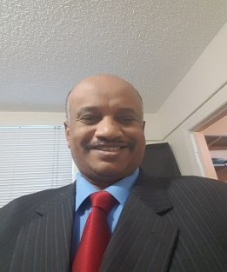
Getachew Woldeyesus Sylvia Waterer
President, SAISIA Board Executive Director, SAISIA

Sample Speaker/Presenter Release Form

COPYRIGHT RELEASE FOR SPEAKERS/PRESENTERS
This form is provided to you as a speaker/presenter at Saskatchewan Association of Immigrant Settlement and Integration Agencies (SAISIA) events/conferences/summits. SAISIA would like to capture your presentation in audio and/or video format. To that end, we want to make certain that both you and SAISIA have the necessary rights and protections to continue to benefit from your presentation. At the end of this process, a copyright release will be generated covering the captured presentation (“Recording”) and use of all accompanying materials (“Materials”).
SAISIA will hold the copyright to the Recording and would like to have the option to continue to use the Recording and Materials. In addition to creating an archive copy for educational purposes, possible uses of the Recording include, but are not limited to, inclusion in SAISIA websites and delivery to the public via distribution partners.
Finally, please understand that there is nothing in this Speaker Release requiring you to give your ideas to SAISIA. If you plan to give the same talk somewhere else, there is certainly nothing in this release that would keep you from that engagement. And, unless there is an exception called out to you by SAISIA then SAISIA would be very happy to provide a copy of the Recording to you and will grant you a non-disclosure license to use the Recording in any way you’d like.
INFORMATION ABOUT YOU
Name:_______________________________________________________________________________
Title:_________________________________________________________________________________
Organization:__________________________________________________________________________
Address:______________________________________________________________________________
Email:________________________________________________________________________________
Telephone/Cellular:____________________________________________________________________
INFORMATION ABOUT YOUR PRESENTATION
Title:_________________________________________________________________________________
Dates:________________________________________________________________________________
Location:_____________________________________________________________________________
Check each of these boxes to agree to the conditions of this release:
 I give permission to SAISIA to capture my presentation identified above.
 I give SAISIA permission to use my name, likeness and biographic information to use, promote or exploit the Recording or any derivative work of the Recording.
 I acknowledge that SAISIA in capturing my presentation, will become the copyright owner of the Recording. To the extant I have any rights in the Recording, I hereby assign all my rights, title and interests in and to the Recording to SAISIA.
 I understand that possible uses of the Recording by SAISIA include, but are not limited to, inclusion in the SAISIA website and delivery to the public via distribution partners.
 I understand that SAISIA grants me the nonexclusive right to exploit the Recording in any manner. I understand that I have the right to ask SAISIA to provide me a copy.
 I acknowledge that this Release is governed by Canadian law and is a legally binding agreement.
 I verify that I have authority to enter into this agreement and that I will be bound by its terms.
CREATIVE COMMONS LICENSING
SAISIA is committed to using your presentation in ways that make sense to you. To that end, we reserve the right to freely distribute your work.
YOUR ACCOMPANYING MATERIALS
Please complete this section to let us know about any accompanying materials (Materials) you may have for distribution with the Recording of your presentation. Example include; PowerPoint presentations, handouts, graphs or charts. If you later become aware of additional Materials or otherwise need to amend this list, please contact us at the email address provided at the end of this process.
Materials of which I am the sole copyright owner and for which I grant SAISIA an exclusive, royalty-free, irrevocable, transferable license to use in support of the Recording in any medium now known or hereafter created:
Materials of which I am NOT the sole copyright owner but have permission to use and to grant SAISIA full use in support of the Recording in any medium now known or hereafter created:
Materials of which I am not the sole copyright owner but which fall within the fair use principals of copyright law to be distributed and used by myself And SAISIA in support of the Recording:
Materials of which I have not received express permission to use and of which I am unsure of the copyright implications.
Signature:_____________________________________________________________________________
Date:_________________________________________________________________________________
Please return the signed form to SAISIA prior to your Speaking Engagement or Presentation.

Sample Delegate Release Form

DELEGATE RELEASE/ LIABILITY FORM
I authorize my photograph, picture or likeness, and voice to appear in any documentary, promotion (including advertising), television, video, website or radio coverage of the event, without compensation.
I hereby release, waive liability, discharge, hold harmless, indemnify, and covenant not to sue the organizers – the Saskatchewan Association of Immigrant Settlement and Integration Agencies (SAISIA), The SAISIA Summit Organizing Committee, the sponsors, from any and all liability incurred in the conduct of, and my participation in, this event. This includes owners, lessors, and lessees of premises, municipalities, government agencies, successors, heirs, and assigns.
I have completely read this document and fully understand its contents. I acknowledge that I have given up substantial rights by accepting this document and that I do so voluntarily. My signature attests to this on behalf of myself and my executors, personal representatives, administrators, heirs, next-of-kin, successors, and assigns.
Participant Signature
________________________________________________________________________________
Signature Date and Place
________________________________________________________________________________

Sample Request for Proposals (RFP) Printing

REQUEST For PROPOSALS, (RFP’s)
Date of Tender Issue 07/20/18
Last date of Tender Issue 07/27/18
Opening of Tender Bid 07/28/18

PRINTING Saskatchewan Association of Immigrant Settlement Integration Agencies (SAISIA) hereby requires one entity to deliver PRINTING services for an upcoming event. It is important to note that whoever wins the BID will be designing the event ART for all the of following…
SAISIA 2nd Annual Integration Summit
September 5, 6, & 7th 2018
Delta Regina Hotel, Regina, Saskatchewan
Program 8 ½ color glossy – 16 pages
200 English
50 French
Signage Banner
Canvas w/grommets
25 feet x 5 feet
Break – Out
5 Signs 3feet x 3feet, bristle board
• Break Out #1
• Break Out #2
• Break Out #3
• Break Out #4
• Break Out #5
Portfolios Twin Pocket
Samples required
Note Pads Samples required

Please direct responses to Peggy Robillard, PNT Events Coordinator SAISIA, Email: peggy.robillard@saisia.ca
W:306.651.4398 C:306.850.6524

Sample Request for Proposals (RFP) Venue

REQUEST For PROPOSALS, RFP’s
Date of Tender Issue 03/20/18
Last date of Tender Issue 03/27/18
Opening of Tender Bid 03/28/18
Venue
Saskatchewan Association of Immigrant Settlement Integration Agencies (SAISIA) hereby requires one entity to provide a venue for an upcoming event:
- SAISIA 2nd Annual Integration Summit
- September 5, 6, & 7th, 2018
- Regina, Saskatchewan

Hotel Room Block (50 ppl. /night) September 4,5 and 6th, 2018
Accommodation Discount
Three (#3) Complimentary Executive Suites
Plenary #300 ppl.
Rounds of ten, set for #6 ppl. facing front
Stage, Skirted table with 4 chairs, Podium with Microphone
Hard Wired Internet
#5 Break-Out Rooms, 50# ppl. Rounds. Podium, Flip Chart w/markers
Catering /PORK FREE Menu…
Three Hot Breakfasts
Three Hot “Customized” Lunches – event theme
Five Coffee Breaks, with Diabetic Snacks
*Leftovers to be given to Host City less fortunate.
*Bill by Consumption ONLY
Audio Visual No PATCH FEE
Rehearsals MUST begin at 1:00 p.m. on September 4th (day before), the chosen AV provider MUST assure SAISIA of this crucial aspect.
Bi-Lingual Live Streaming English and French
Picture on Picture video streaming
Bilingual Interpreters System, aka. Translation Booth
Headsets
Network like programming
Three camera inputs
Two Screens, draped
One Panasonic HD AG-AC160A video camera w/tripod and w/operator
One Panasonic HD AG-AMC40P video camera w/tripod – locked down
Live broadcasting producer
Detailed viewer analytics and unlimited technical support before, during and after the event.
Editing and post production of the recorded files with a full recording of the event in English.
High definition, network quality, live streaming video production.

Please direct responses to Peggy Robillard, PNT Events Coordinator SAISIA,
Email: peggy.robillard@saisia.ca
W:306.651.4398 C:306.850.6524

Sample Request for Proposals (RFP) Interpreters

SAISIA 2nd Annual Integration Summit
September 5, 6, & 7th 2018
Delta Regina Hotel, Regina, Saskatchewan

REQUEST For PROPOSALS, (RFP’s)
Date of Tender Issue 07/20/18
Last date of Tender Issue 07/27/18
Opening of Tender Bid 07/28/18

Two Interpreters needed
Saskatchewan Association of Immigrant Settlement Integration Agencies (SAISIA) hereby requires one entity to deliver Interpreting services for an upcoming event.

Program Three Days
Interpreters will be required to attend Rehearsals, 1:00 p.m. September 4th, 2018
Main Plenary, Trentino/Tuscany room, Delta Regina Hotel, 1919 Saskatchewan Drive, Regina, Saskatchewan.

Please direct responses to Peggy Robillard, PNT Events Coordinator SAISIA,
Email: peggy.robillard@saisia.ca
W:306.651.4398 C:306.850.6524

Sample Request for VIP Letter of Invitation
SASKATCHEWAN SECOND ANNUAL INTEGRATION SUMMIT
The Honorable Ahmed D. Hussen MP
Minister of Immigration Refugees and Citizenship Canada
365 Laurier Avenue West
Ottawa, Ontario, K1A 1L1

Dear Minister Hussen MP:
The Saskatchewan Association of Immigrant Settlement and Integration Agencies (SAISIA) would like to personally invite you to address our delegates at the second annual integration summit to be held in Regina, SK at the Delta Regina, September 5-7, 2018.
This year’s annual integration summit is designed to focus on accomplishing three goals:
1) Ensure that the entire Saskatchewan settlement system is aware of current investments and pressures facing the settlement system;
2) Engage all stakeholders in the identification of key priorities during the remainder of the current fiscal cycle (Sept 2018-March 2020); and
3) To provide strategic advice to IRCC on the design of Call for Proposals 2019 on both essential priorities and negotiating guidelines.
WE recognize that you are very busy and would be equally honored by a written greeting and picture for our summit program. Please do not hesitate to contact Peggy Robillard PNT Events Coordinator at peggy.robillard@saisia.ca if you have any questions.
I look forward to your response on your availability to attend this wonderful event.

Yours sincerely,
Sylvia Waterer
Executive Director
SAISIA

Sample of VIP Checklist – Premiers Office

Name of Event: | Annual Integration Summit
Sponsoring Organization: | Saskatchewan Association of Immigrant Settlement and Integration Agencies

LOGISTICS
Event Date | Wednesday September 5th
Time | 9am
Address | 1919 Saskatchewan Drive, Regina. SK
Parking | Underground Parking
Contact Person | Peggy Robillard
Phone Number(s) | 306.850.6524
Attire | Business attire

ARRIVAL
Who will greet the Premier? | Peggy Robillard
Where? | Delta Regina, Campania A “Green Room”
What Time? | 8.45 am

ORDER OF EVENTS

Who will introduce the Premier? | SAISIA MC – Anthony Olusola
What time will the Premier be speaking?  Length of time for the allotted remarks: | 9:10 a.m.  15 minutes
Programme Order | Premier of Saskatchewan - FIRST
Who is emcee? | SAISIA MC – Anthony Olusola
Who should Premier acknowledge? | Immigration Refugees and Citizenship Canada (IRCC) as funders of event, SAISIA as organizers, Sector and Partners in attendance
Description of physical set-up  (e.g.: riser, podium, microphone, head table) | Riser with microphone in plenary space

OTHER
Ticket for Premier and a Guest? | No ticket required
Is there a cost applicable? | None
Where can the tickets be picked up? | No ticket required
Where will the Premier’s Guest be seated? | At a VIP table with Premier before greetings
Number of confirmed guests attending? | Approx. 175
Of those confirmed, any other Ministers & MLAs? | No. The Mayor is being invited but not confirmed and the Director General of Settlement and Integration Policy for the Federal Department of Immigration, Refugees and Citizenship Canada will be present.
Has Media been invited? | No
Will this be televised or recorded? Provincial or National? | Livestreamed online to conference participants but only the plenary sessions being recorded not the Introductions and Greetings
Is this event open to the public? | No
If so, what is the cost for public to attend? | No
What social media platforms will the event be promoted on? | SAISIA will be Live Streaming the entire event
**Protocol – for your planning purposes, the Premier speaks first at events,
unless the Queen, Prime Minister or Lieutenant Governor are in attendance

ADDITIONAL INFORMATION

Sample Service Provider Invitation

Dear (name or SPO)

Your organization is invited to participate in the
Second Annual Integration Summit
hosted by Saskatchewan Association of Immigrant Settlement and Integration Agencies (SAISIA).

The event will be held on September 5 – 7, 2018 in Regina, SK at the (Delta Regina Hotel, 1919 Saskatchewan Drive).

This year’s annual integration summit is designed to focus on accomplishing three goals: 1) ensure that the entire Saskatchewan settlement system is aware of current investments and pressures facing the settlement system; 2) engage all stakeholders in the identification of key priorities during the remainder of the current fiscal cycle (Sept 2018-March 2020); and 3) to provide strategic advice to IRCC on the design of Call for Proposals 2019 on both essential priorities and negotiating guidelines.

An agenda for day 1 and 2 has been drafted by IRCC and has been attached to this invite to allow you plenty of time to review the agenda to come prepared for the two-day discussion.
Day 3 of the event will focus on professional development and will be developed by SAISIA in conjunction with an advisory committee.
SAISIA is looking for 12-15 participants to sit on the advisory committee. Committee members will be selected from across the province and will ensure representation of urban and small centers as well as new and experienced Service Providers (Francophone and Anglophone) across various program streams.

Additional Details:
- Attendees must RSVP (an Eventbrite invitation is on its way to you!) by (date) to ensure participation in the event. IRCC will be supporting the participation of (#) individuals from your Organization. Preference is for the Executive Director and Program Managers/Team Leaders to attend. If you are unable to attend, an alternate participant can be selected to represent your Organization.

- For IRCC funded SPOs travel costs for this event will be covered through your contribution agreement.

- For non-IRCC funded SPOs who are unable to cover their transportation please contact (email) to further discuss options.

- Livestream will be available on Day 1 and 2 (plenary sessions only) if you are unable to attend in-person.

- Simultaneous interpretation will be available during the event for both in-person and livestream participants. If you require simultaneous interpretation during the breakout sessions please let (email) know by May 15th, 2018.

- If you would like to sit on the advisory committee, please contact (email) by May 1st, 2018 to put your name forward.

We look forward to your organization’s participation in this exciting event.
Please do not hesitate to contact us at (email) with any questions regarding the summit.

Thank you,

Sylvia Waterer
Executive Director
SAISIA

Sample Save The Date

SAVE THE DATE

To Whom it May Concern:
After completing a sector survey on the proposed dates for the SAISIA Summit 2018. The following date was agreed upon September 5,6, and 7, 2018. The Summit will be held in Regina, Saskatchewan.
Venue Bids are being gathered and will be evaluated. SAISIA will issue an advisory as soon as we have more to report.

Sample Press Release

FOR IMMEDIATE RELEASE Contact: Peggy Robillard, SAISIA
Phone: Cell # 306-850-6524
Email: peggy.robillard@saisia.ca

SAISIA GRAND OPENING
Wine & Cheese Reception

Saskatoon Saskatchewan CANADA JUNE 13, 2019 [ The voice of Saskatchewan’s Settlement sector (SAISIA) has moved to a new location #104-407 Ludlow Street, Saskatoon, Saskatchewan. Wine & Cheese Come & Go reception starts at 1:00 p.m. with Press Conference to commence at 2:00 p.m. Come meet the staff and Board Members who represent the following organizations]

Regina Open Door Society
Saskatchewan Intercultural Association
Global Gathering Place
Regina Immigrant Women Centre
Saskatoon Open Door Society
Moose Jaw Multicultural Council
International Women of Saskatoon
Humboldt Regional Newcomer Centre
Assemble’e communautaire fransaskoise

####

If you would like more information about this event please call Peggy Robillard, PNT Events Coordinator SAISIA at 306-850-6524 or email: peggy.robillard@saisia.ca

www.saisia.ca

Sample IRCC National Sector Survey
Survey for Small Centre Conference Participants
This survey will take approximately 15-20 minutes to complete. For organizations, we request that one survey per organization be completed by management. Your participation and identity will be kept strictly confidential- your personal information will not be used in analysis. Participation in this survey is voluntary and you may end it at any time. Please submit your response by Wednesday February 28, 2018.
Respondents can change their answers on any survey page until they complete the survey.
On March 26 – 28, there will be a 3-day National Small Centre Consultation in Red Deer Alberta for organization that deliver services to newcomers in communities outside major urban cities.
The consultation will provide a forum for input into the next call for proposal’s priorities and guidelines from a small center perspective and communication with IRCC. The conference will result in the creation of a document which highlights small center communities’ highest priorities for CFP 2020 in each program area; language training, employment, support services, information and orientation, community connections, indirect, and needs assessment and referral.
The purpose of this survey is to provide you the opportunity to have input into the direction and agenda of the conference. It is our hope that we can build this conference collectively.
In order to allow this survey to provide direction for the conference, please complete it by Wednesday, February 28th.
- What is the name of your Organization?
______________________________________________________________________
- Noting that flights to Red Deer are only available from Calgary and that Red Deer is a two-hour drive north of Calgary, would you prefer that the conference runs from:
  - Monday, March 26 at 9:00am and end Wednesday, March 28 at 12:00pm
  - Monday, March 26 at 12:00pm and end Wednesday March 28 at 4:00pm
- Would you like Monday and Tuesday evening to be left open, or would you like to attend a social event, such as dinner and a time to visit or a wine and cheese? Note this will not be a funded activity.
- A social event
- Free evenings
- Other (please specify)

Organization Programs and Services
- Please identify how many communities you serve? __________________________
- What size of community is your organization located in?
Population under 10,000 and/or 20+ unique clients annually
- Population 10,000 – 35,000 and/or 50+ unique clients annually
- Population 35,001-150,000 and/or 200+ unique clients annually
- Population greater than 150,000 and/or 1,000+ unique clients annually

- How many employees do you have that are funded by IRCC agreements? ___________________

- Do you have any additional employees (not IRCC funded) working on settlement and integration issues?
  - No
  - Yes, we have ______ employees

- Which of these bodies provide funding to your organization?
  - Federal government
  - Provincial government

  - Municipal government
  - United Way
  - Community Foundation
  - Private donations
  - Other (please specify) ______________

- Which of the following Settlement Services does your organization offer (select all that apply)?
- Needs Assessment
- Information and Orientation
- Community Connections
- SWIS/NISW/Youth
- Francophone
- Employment/Labor Market
- LIP/RIF
- Support Services
- Seniors
- Women
- Mental Health
- Language
- Language Assessment
- Other (please specify) ___________

- Which of the following Settlement Services does your organization presently not offer but you believe is most important?
- Needs Assessment
- Information and Orientation
- Community Connections
- SWIS/NISW/Youth
- Francophone
- Employment/Labor Market
- LIP/RIF
- Support Services
- Seniors
- Women
- Mental Health
- Language
- Other (please specify) ___________

- Which employment related area(s) do you believe require more attention in small centers?
- Foreign Qualification Recognition
- Career Planning
- Labor Market Knowledge
- Essential Skills Training
- Technical Training
- Job Search and Job Training
- Job Retention
- Self-employment
- Mentorship
- None
- Other (please specify) ___________________________
11. Which Community Connections related area(s) do you believe require more attention in small centers?
- Outreach
- Newcomer Information
- Orientation to Public Services
- Children and youth
- Capacity Building for Public Services and Structures
- Civic Engagement
- Settlement Workers in School
- Conversation Circles
- None
- Other (please specify) ____________________

12. Which Support Services do you believe require more attention in small centers?
- Childcare
- Transportation
- Mental Health Support
- Crisis Counselling
- Provisions for Disabilities
- Loans and Grants for Newcomers
- Interpretation
- Translation
- None
- Other (please specify) ______________

- Which language related area(s) do you believe require more attention in small centers?
- Settlement Language Training
- Bridging to Employment
- Workplace Language Training
- Bridging to Education
- None
- Other (please specify) _________________

- Which information and orientation related area(s) do you believe require more attention in small centers?
- ?
- ?
- ?
- ?
- None
- Other (please specify) _________________

- Which needs assessment and referral related area(s) do you believe require more attention in small centers?
- ?
- ?
- ?
- ?
- None
- Other (please specify) _________________

- Do you believe these priorities from CFP 2015 are still priorities for CFP 2019?
(1 = Yes, absolutely - 5= Not at all).
  - Settlement services available in rural, remote, northern and Arctic locations that demonstrate high market demand to ensure broader access outside urban centers through the use of local community partnerships and alternative delivery approaches
1 2 3 4 5
  - Alternative or distance settlement services for rural, remote, northern and Arctic communities
1 2 3 4 5
  - Alternative or distance language training and assessment for rural, remote, northern and Arctic communities that incorporates blended and informal language learning approaches.
1 2 3 4 5

  - Informal approaches to language learning, including conversation circles and volunteer tutor initiatives blended with formal language training such as Language Instruction for Newcomers to Canada (LINC) Home Study and/or part-time LINC offerings in rural/remote communities
1 2 3 4 5

  - Pre-literacy to CLB 4 courses in all rural, remote, and northern communities with significant immigrant populations
1 2 3 4 5

  - Settlement supports in schools in rural, remote, and northern communities that facilitate bridging with community services using the Settlement Workers in Schools program structure
1 2 3 4 5

  - Participation of rural community and francophone community representatives in new and within existing community partnerships such as Local Immigrant Partnerships and RIF
1 2 3 4 5
- Do you see a need for a national small center community of practice?
  - Yes
  - No

- If Yes, what purpose would it serve?
- Decreasing the learning curve of new employees
- Responding more rapidly to customer needs and inquiries
- Reducing work and preventing “reinvention of the wheel”
- Spawning new ideas for products and services
- Other (please specify)______________
- Do you have difficulty accessing data on Immigration and Settlement in your community?
- Yes
- No
- If yes, please specify why:_____________________________________________

- Would you be interested in participating in a national project to acquire standard data for all small communities?
  - Yes
  - No

- Have you heard of the small center tool kit?
  - Yes
  - No

- If yes, have you made use of the small center tool kit?
  - Yes
  - No
  - If no, please specify why not:______________________________________________

- Would an updated version of the small center tool kit be useful to you?
  - Yes
  - No
  - If no, please specify why not:__________________________________________________

- Do you presently use technology to deliver services remotely to clients who live too far away to access in-person services?
  - Yes
  - No

- If yes, what kind of technology do you use?

__________________________________________________________________________________

- What kind of technology would you most like to be able to add to your program delivery in the next five years?

- What is the program you are most proud of that deliver’s demonstrable outcomes to clients?

- Do your clients have access to language training?
  - Yes
  - No

- Classroom based language training?
  - Yes
  - No

- Conversation circles language training?
  - Yes
  - No

- On-Line/blended language training?
- Yes
- No

- Is there a major employer in your community that considers newcomers to be an important source of employees?
- Yes
- No
- If yes, please specify:_____________________________________________

- If yes, do they presently partner with you?
  - Yes
  - No
  - If no, please specify:_____________________________________________________

- What would you need to enhance partnerships?
- ?
- ?
- ?
- ?
- Other (please specify)______________

- Do you have connections to francophone organizations where you refer francophone clients?
  - Yes
  - No
  - N/A

- Public transit is not available in many small center communities. What alternative approaches does your organization use for client transportation?
- Carpool
- Taxi
- Driving lessons
- Other (please specify)__________________

Sample Saskatchewan Language Resource List

Saskatchewan INTERPRETERS
Michael Jackson Louise McCollough
Tel: (306) 757-1665
Cell: (306) 531-7069
Email: dmichaeljackson@sasktel.net Email: louisemcc@sasktel.net

2 interpreters @ $650/day X 3 days = $3,900
2 per diems @ $15/day X 3 days = 90
Total $3,990

We are giving you a reduced rate for a non-profit (the usual fee is $700) and the per diems are also reduced (to cover parking), on the understanding that lunch is provided.
Plus Hotel Accommodation and Travel

Saskatchewan TRANSLATOR
Sebastien Rock
Sébastien Rock
Freelance Linguist | Linguiste pigiste
Trema Language Services, est. 2000
306 Whiteshore Way, Saskatoon, SK, Canada, S7J 4C2
Tax number | No. de taxe: # 801222522RT0001
Web: trema.ca
Email | Courriel : srock@trema.ca
Networks | Réseaux : Translatorscafe , ProZ
LinkedIn: ca.linkedin.com/in/trema
Tel and Text: 1.306.361.6412 (GMT - 6, Always | Toujours)
Skype: srock.ok
Rate: 20 to 23 cents per word

Complete Example of a Pre-Event Checklist

12 Months Prior to Event
• Meet with planning group and brainstorm event ideas
• Create overview of event (name, date & times, objectives, outcomes, description, target audience, estimated attendance, and activities)
• Establish group roles and responsibilities
• Brainstorm, create sponsor benefits document, and secure potential sponsors
4-7 Months Prior to
• Research and apply for additional sources of funding (e.g. grants)
• Begin establishing budget
• elect and secure venue
• If requesting a street closure, contact barricade company layout and obtain nearby consent from businesses
• Research potential bands or other entertainment
3-4 Months Prior to Event
• Develop marketing plan
• Create volunteer plan and overview of duties
• Contact and third-party vendors and reserve activities & logistical services
• Reach out to potential bands or entertainment
• Obtain event and liquor liability insurances
• Complete and submit permit applications, event and liquor liability insurances to the City Clerk
2-3 Months Prior to Event
• Create & proof event poster and/or handouts send to printing company
• Confirm bands or other entertainment with signed contract
• Begin outreach & confirm potential volunteer groups or individuals’ volunteers
• Begin work on press release
• Create Social Media event page and hashtag for your event
1 Month Prior to Event
• Check-in with City to confirm approval of permits
• Begin selling and promoting ticket sales online and/or in person
• Email press release to local media
• Begin distributing event posters to local businesses
• Begin posting event to online event calendars
1-2 Weeks Prior to the Event
• Check RSVP or ticket sales and send final attendee numbers to your caterer
• Re-confirm event dates and times with presenters and performers
• Hold pre-event meetings with 3rd party vendors, managers of the venue, and volunteers.
• Do one last walk-through of venue and all event spaces
• Create a detailed hour-by-hour event timeline for key volunteers and vendors based on meeting conversations and distribute to them
• Create an “Event Day Survival Kit” full of needed items: pens, sharpies, highlighters, tape, scissors, etc.
• Make nametags or lanyards to designate staff and volunteers
• If a ticketed event, send final information to attendees including directions, maps, and last-minute details
• Discuss severe weather logistics with planning team (if hosting an outdoor event)
1-2 Days Prior to the Event
• Create a final to-do list to ensure all of your tasks are completed
• Make sure you have Important contact numbers for venue managers, 3rd party vendors, volunteers, or non-emergency police in one place and easily accessible on the event day. It is helpful to laminate these and put on your staff lanyards
• Reconfirm schedule with your caterer
• Deliver materials/equipment to the venue site (if possible)

Sample Event Software Requirements

Providing your organization plans to have more than 5 events per year (event-by-event capabilities) and you are planning to initialize a sponsorship strategy then the purchase of event management software would be justifiable. It is important that the software be able to handle at least 10 events per year minimum. Finally, before signing with a company make sure they are giving you everything you need. On-site, In-person training PLUS one-year of 24/7 technical assistance at no additional cost to you.
CONTACT LISTS committees, delegates, vendors, sponsors
SMS
DIRECT MAIL
EMAIL

MEETING CATERING VENUE TRAVEL
live food cost equipment/asset tracking package creation
interactive dietary space planning booking portal
virtual tracking staff management room block
vendor/exhibitor/sponsor mgmt.
floor plan simulation

DELEGATE AUDIO VISUAL
guest booking live streaming
registration management video mgmt. interface this platform is highly
attendee self-service functional.
Ticketing some venue’s do not have the capability/
badge creation bandwidth.
custom seating check with your AV provider and see what social media
tracking app., they recommend. Example: SLIDO
survey
live streaming
wireless connectivity FINANCE
relationship mapping revenue and budgeting software
trends
behavior analysis
multi-channel requests
email
phone
web
social media

COST: software $10,000.00 or more
MONTHLY ADMIN. FEE: $250.00 to $500.00/month

LINK to SAISIA Summit Audio Visual Plan, Created by Sami Khiami, PNT “IT” Specialist, AAISA

..\..\..\..\..\..\..\Documents\SAISIA Summit 2018\Copy of AV Plan SAISIA_August28_V3.pdf

THANK YOU
The Saskatchewan Association of Immigrant Settlement and Integration Agencies (SAISIA) would like to thank you for your support without you this manual would not have been possible.

@COPYWRITE SAISIA 2019

